TEXT : FINITE AUTOMATA ALGORITHM

PATTERN : TEXT

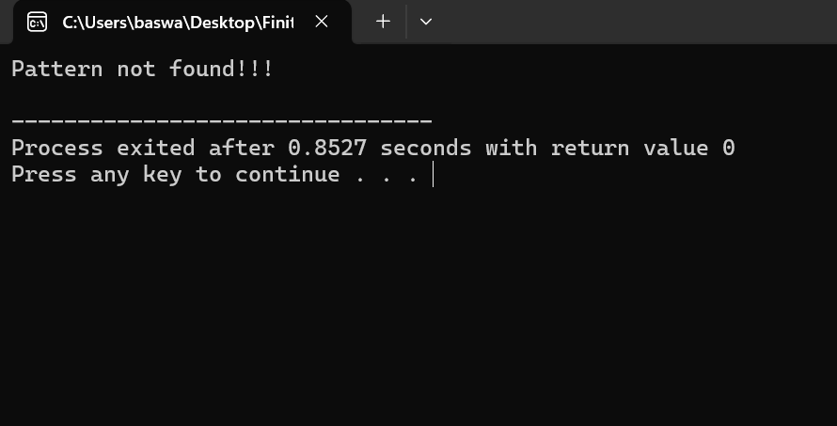

TEXT : AABAACAADAABAABA

PATTERN : AABA

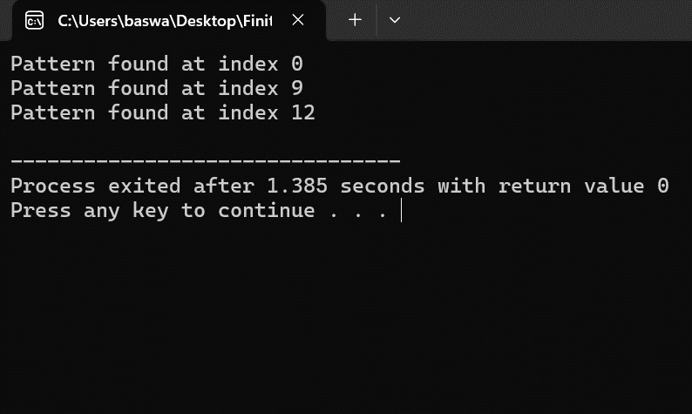

TEXT : THIS IS A TEST TEXT AND TEXT

PATTERN : TEXT

